**PIZZA SALES SQL QUERIES**

**A. KPI’s**

**1. Total Revenue:**

SELECT SUM(total_price) AS Total_Revenue FROM pizza_sales;

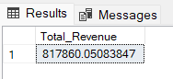

**2. Average Order Value (AOV)**

SELECT (SUM(total_price) / COUNT(DISTINCT order_id)) AS AOV

FROM pizza_sales

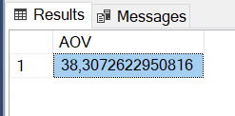

**3. Total Pizzas Sold**

SELECT SUM(quantity) AS Total_pizza_sold FROM pizza_sales

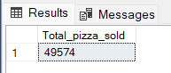

**4. Total Orders**

SELECT COUNT(DISTINCT order_id) AS Total_Orders FROM pizza_sales

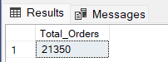

**5. Average Pizzas Per Order**

SELECT CAST(CAST(SUM(quantity) AS DECIMAL(10,2)) /

CAST(COUNT(DISTINCT order_id) AS DECIMAL(10,2)) AS DECIMAL(10,2))

AS Avg_Pizzas_per_order

FROM pizza_sales

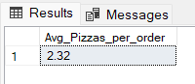

**B. Daily Trend for Total Orders**SELECT DATENAME(DW, order_date) AS order_day, COUNT(DISTINCT order_id) AS total_orders

FROM pizza_sales

GROUP BY DATENAME(DW, order_date)

***Output:*** 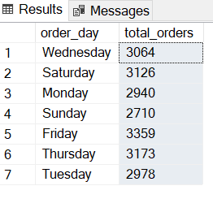

**C. Monthly Trend for Orders**

SELECT DATENAME(MONTH, order_date) AS Month_Name, COUNT( DISTINCT order_id) as total_orders

FROM pizza_sales

GROUP BY DATENAME(MONTH, order_date)

ORDER by total_orders DESC

***Output***

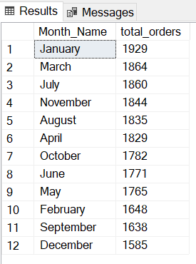

**Hourly Trend for Orders:**

SELECT DATEPART(HOUR, order_time) AS order_hour, COUNT( DISTINCT order_id) as total_orders

FROM pizza_sales

GROUP BY DATEPART(HOUR, order_time)

ORDER by total_orders DESC

***Output***

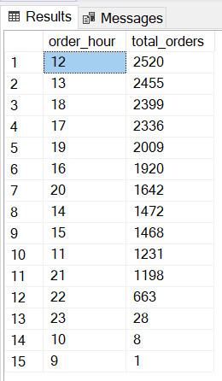

**D. % of Sales by Pizza Category**

SELECT pizza_category, CAST(SUM(total_price) AS DECIMAL(10,2)) as total_revenue,

CAST(SUM(total_price) * 100 / (SELECT SUM(total_price) from pizza_sales) AS DECIMAL(10,2)) AS PCT

FROM pizza_sales

GROUP BY pizza_category

***Output***

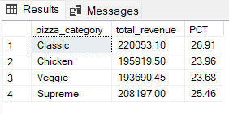

-- % of Sales by Pizza Category in a specific month like january

SELECT pizza_category, CAST(SUM(total_price) AS decimal(10,2)) AS Total_Revenue ,CAST((SUM(total_price)/(select SUM(total_price) from pizza_sales where MONTH(order_date)=1) *100) AS decimal(10,2)) as PCT

from pizza_sales

WHERE MONTH(order_date)=1

GROUP BY pizza_category

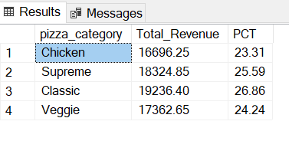

**E. % of Sales by Pizza Size**

SELECT pizza_size, CAST(SUM(total_price) AS DECIMAL(10,2)) as total_revenue,

CAST(SUM(total_price) * 100 / (SELECT SUM(total_price) from pizza_sales) AS DECIMAL(10,2)) AS PCT

FROM pizza_sales

GROUP BY pizza_size

ORDER BY PCT DESC

***Output***

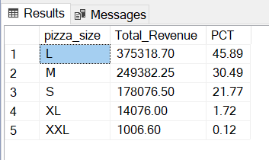

-- percentage of revenue for each pizza size in the "Classic" pizza category.

SELECT pizza_size, CAST(SUM(total_price) AS decimal(10,2)) AS Total_Revenue, CAST((SUM(total_price)/ (SELECT SUM(total_price) FROM pizza_sales WHERE pizza_category='Classic' )*100) AS DECIMAL(10,2)) as PCT

FROM pizza_sales

WHERE pizza_category='Classic'

GROUP BY pizza_size

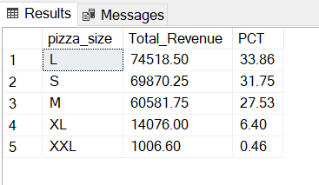

--Chicken

SELECT pizza_size, CAST(SUM(total_price) AS decimal(10,2)) AS Total_Revenue, CAST((SUM(total_price)/ (SELECT SUM(total_price) FROM pizza_sales WHERE pizza_category='Chicken' )*100) AS DECIMAL(10,2)) as PCT

FROM pizza_sales

WHERE pizza_category='Chicken'

GROUP BY pizza_size

HAVING pizza_size='M'

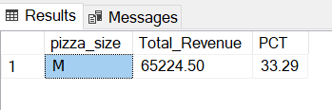

**F. Total Pizzas Sold by Pizza Category**

SELECT pizza_category, SUM(quantity) as Total_Quantity_Sold

FROM pizza_sales

GROUP BY pizza_category

ORDER BY Total_Quantity_Sold DESC

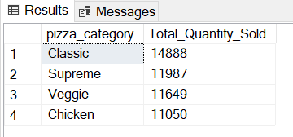

-- Total Pizzas Sold by Pizza Category in February

SELECT pizza_category, SUM(quantity) as Total_Quantity_Sold

FROM pizza_sales

WHERE MONTH(order_date) = 2

GROUP BY pizza_category

ORDER BY Total_Quantity_Sold DESC

***Output***

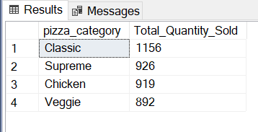

**G. Top 5 Pizzas by Revenue**

SELECT Top 5 pizza_name, SUM(total_price) AS Total_Revenue

FROM pizza_sales

GROUP BY pizza_name

ORDER BY Total_Revenue DESC

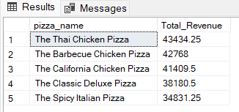

**H. Bottom 5 Pizzas by Revenue**

SELECT Top 5 pizza_name, SUM(total_price) AS Total_Revenue

FROM pizza_sales

GROUP BY pizza_name

ORDER BY Total_Revenue ASC

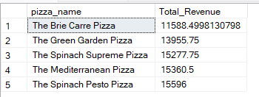

**I. Top 5 Pizzas by Quantity**

SELECT Top 5 pizza_name, SUM(quantity) AS Total_Pizza_Sold

FROM pizza_sales

GROUP BY pizza_name

ORDER BY Total_Pizza_Sold DESC

***Output***

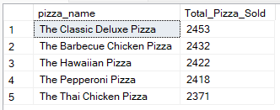

**J. Bottom 5 Pizzas by Quantity**

SELECT TOP 5 pizza_name, SUM(quantity) AS Total_Pizza_Sold

FROM pizza_sales

GROUP BY pizza_name

ORDER BY Total_Pizza_Sold ASC

***Output***

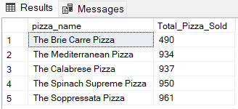

**K. Top 5 Pizzas by Total Orders**

SELECT Top 5 pizza_name, COUNT(DISTINCT order_id) AS Total_Orders

FROM pizza_sales

GROUP BY pizza_name

ORDER BY Total_Orders DESC

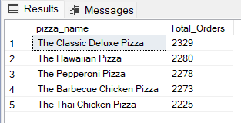

**L. Borrom 5 Pizzas by Total Orders**

SELECT Top 5 pizza_name, COUNT(DISTINCT order_id) AS Total_Orders

FROM pizza_sales

GROUP BY pizza_name

ORDER BY Total_Orders ASC

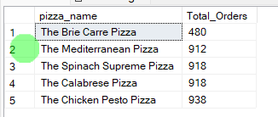

***So in this way we solved all our problem statements which are provided by the client for us and we haved selve dit in Ms SQL Server now we will be preparing our daschboardand we will be comparing pur result.***

***Now we will go a head and connect our power bi desktop to Ms SQL Server database***